rPOD-8.4
Owner’s Manual for Model rPOD-8.4

Professional Sound, Lighting, and Motion Controller

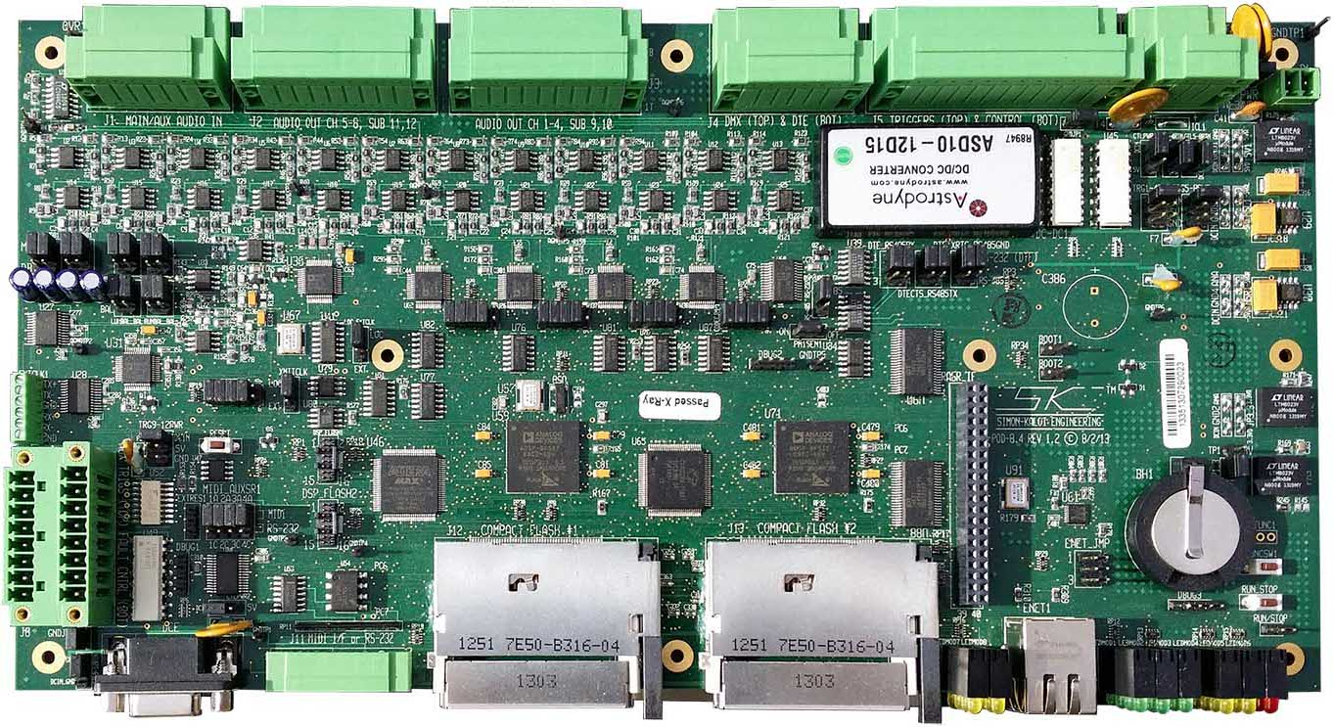

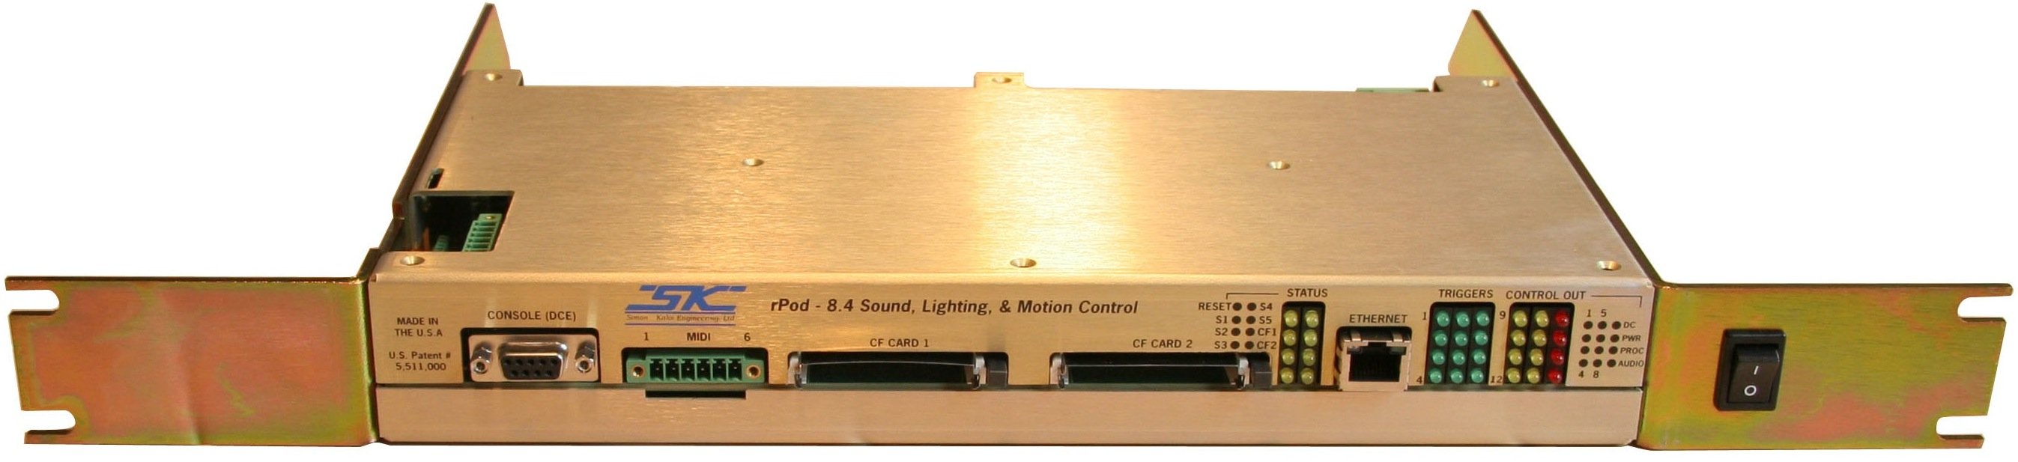

Revision 1.2A
Updated May 1, 2017
Authored by D. Kaloi, R. Simon
© 2009-2017 Simon-Kaloi Engineering, Ltd.
TABLE OF CONTENTS
Important Safety Instructions 4
Introduction 5
System Block Diagram 6
Optional Support Hardware and Software 7
J1 MAIN/AUX Audio Input Connector 9
Note about Audio Outputs: 9
J2 Audio Output Software Channels 5-8 / Subwoofers 11 and 12 9
J3 Audio Output Software Channels 1-4 / Subwoofers 9 and 10 11
J4 DMX and Serial DTE/RS-485 11
J5 Input/Output Connector 13
J6 DC Power Supply Input 16
Power Switch Jumper 16
Power Switch Interface 16
Boot Jumpers 16
Real-Time Clock Backup Battery 16
RASR and Auxilary Interface 17
Run/Stop Switch and Interface 18
Status Display 19
Ethernet Interface and Jumpers 19
J12 and J13 Compact Flash Connectors 20
J11 MIDI/Aux Serial Interface 20
Console Serial Port (DCE) 20
J8 Auxiliary Triggers and Fault Control Status 21
MIDI/AUXSR & Ext Reset 21
External Clock Interface 22
Reset Switch 22
AuxDSP Control Jumpers 22
CODEC Control Jumpers 22
Software 23
Files 23
Sound Files 23
Control Files 23
Programmer 24
Hardware Setup: 24
Channel Configuration: 24
Control Recording: 25
Loading and Saving Control Recording Sessions: 26
Program Editor: 26
DMXEdit 27
Loading a New Operating System 28
Warranty 30

Important Safety Instructions

- Always follow basic safety precautions when using this product to reduce risk of injury from fire or electrical shock.

- Read and understand all instructions in the owner’s manual before using this product. Observe all warnings and instructions marked on the product.

- Disconnect this product from electrical power source before cleaning. Clean exposed parts with a damp soft cloth. Do not use cleaning agents or aerosols.

- Do not use this product near water or when wet. If this product gets wet, disconnect from power source immediately. Do not reconnect power until the unit has been dried thoroughly.

- This product should be mounted in a rack or placed on stable surface prior to use.

- Do not use this product if it has been dropped or damaged. Contact manufacturer for service or repair.

- Product should be mounted or placed in a location where cords and cables do not present a hazard.

- Cords and cables should be routed in a manner to prevent damage or abrasion. Use proper strain relief. Always make connections and disconnections with power off.

- Use power sources only as marked on the unit, specifically recommended in this manual or as supplied by the manufacturer. Do not overload electrical outlets or extension cords. This may increase risk of fire or electrical shock.

- Do not operate this product in rain, snow or other adverse conditions.

- If this unit does not operate properly, refer to the troubleshooting section of this manual. If the problem cannot be resolved contact the manufacturer for service or repair.

- No user serviceable parts are in this product.

- Removing the cover may cause exposure to dangerous voltages or other risks as well as void the warranty.

Introduction
The rPOD-8.4 digitally stores and plays back synchronous 8.4 digital audio channels along with synchronous lighting and control information. The 8.4 channels of digital audio can be arranged as five stereo channels with two subwoofer, eight independent mono channels, or combinations of mono and stereo channels, along with synchronous lighting and control information. A multi-channel polyphony feature allows numerous audio sounds to play on the same channel(s). Audio and control information are stored on Compact Flash Cards (CF cards) that are not included. Files can be efficiently transferred to and from CF cards using a PC with a CF card reader/writer or via a local area network (LAN) and the rPOD’s Ethernet Port and an FTP file transfer program. The rPOD plays uncompressed .WAV formatted stereo or mono files with 16 bits of resolution with at a sampling rate of up to 44.1Khz. The rPOD-8.4 hardware is capable of 24 bit audio resolution and up 48Khz sampling rate (with future operational software) however, higher sampling and especially higher bit resolution will reduce performance with certain functions such as the number of tracks that can be played with polyphony. Balanced/unbalanced audio lineouts and balanced/unbalanced line and microphone inputs are also provided. The microphone inputs feature a low-noise preamp with programmable gain. The microphone and line input signals can be processed via an input DSP that is independent from the playback DSPs. The powerful DSPs include functions such as seven-band EQ, spatial expansion and compression, and crossover filtering. Twelve optically isolated trigger inputs, 12 direct output controls, 12 direct outputs, up to three RS-232 interfaces, MIDI In/Out, 10/100 Base-T Ethernet, DMX-512 in/out, and a spare RS-485 for additional control are all included. There is also a RASR I/F for future expansion functionality. The on-board real-time clock facilitates event triggering.

The rPOD-8.4 works with the powerful SKE Sequence Programming Language (SPL), that allows the user to write simple to complex scripts that tell the rPOD what to do and when and how to do it. Scripts can be written on PC, Mac, mobile device, or any device that can output a text file format. Programs such as Word and Notepad are just some of the programs that can output this file format. For more on this see the SKE Software Description Manual. It can be downloaded at the www.skeng.com website.

Programming control information can be achieved via the SPL, with DMX512 console, or with a PC and the free SKE Programmer Software.

The rPOD-8.4 has two main Digital Signal Processors (DSPs). These devices act as the brains of the rPOD and act as user-programmable logic controllers that can be tailored to meet your system needs.

The rPOD can be used in countless applications including robotics, animated characters, “messages on hold”, annunciators, public address systems, on-board ride-car audio, kiosks, and public safety. Playback can be triggered from several sources including motion sensors, switches, logic signals, door and pressure sensors, timed events, and much more. It can be purchased in packaged or bare board form. The unique design behind the rPOD is patented.

WARNING: READ THIS MANUAL THOUROUGHLY BEFORE BEGINNING USE OF THE rPOD. ALL THE INFORMATION IN THIS MANUAL IS BELIEVED TO BE CORRECT HOWEVER IS SUBJECT TO CHANGE.

System Block Diagram

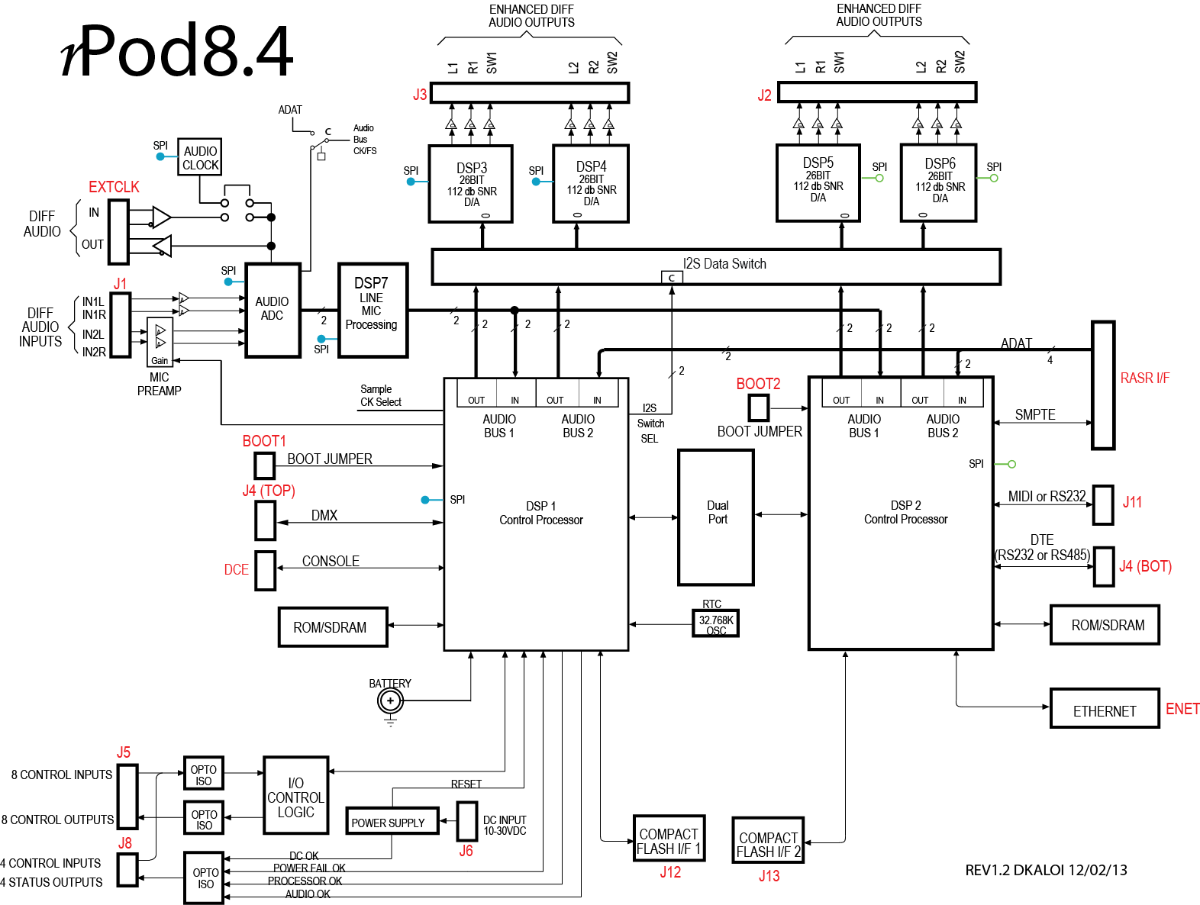

Optional Support Hardware and Software

You can communicate with the rPOD, issue sequence commands, and receive back diagnostics and other information with a computer (PC, Mac), or other device that can implement a terminal program. There are two ways to communicate with the rPOD, RS-232 serial or Ethernet. Each is method is addressed below:

RS-232
If you have a computer or device with a built-in RS-232 port, you will need a standard modem style 9-pin female to male serial cable. Connect the female end to the computer and the male to the rPOD’s Console port. You can also connect to the rPOD’s DTE port (see the J4 DMX and Serial DTE Section of this manual for connection scheme for the DTE Port). You will also need a terminal program such as Hyperterminal for the PC and CoolTerm for the Mac. You want to directly connect to the computer’s COM port. The default settings for the terminal program should be 115.2Kbps, 1 stop bit, no parity and no hardware handshaking. You will also want to set the terminal to echo characters typed locally and wrap text that exceeds column width. If you do not have a computer or device with a built-in RS-232 port but that does have a USB port, you can use a high-speed USB to RS-232 converter such as the device linked below:

http://www.tripplite.com/EN/products/model.cfm?txtModelID=3914

Once connected, you should see a startup screen similar to the one shown below:

Startup.seq is running
=========================================================
Simon-Kaloi Engineering Ltd.rpodP1 Audio and Control System
Revision 1.48, File:rpodP1a048 17SEP2013 44.1K/16bit
=========================================================
DATE: Wed 06/03/26 11:47:01 PM
File System Version: HCC_FAT_LFN ver:2.60
Volume 0 is active
Drive A|total: 4.095G bytes free: 3.919G bytes
|used : 175.473M bytes bad: 0 bytes
Directory of RPODTEST1:
---------------------------------------------------------
08-21-09 09:35AM 4096 ._.Trashes
12-20-84 09:41PM 2 m3s2.tmp
08-21-09 09:35AM <DIR> .Trashes
09-16-13 10:29AM <DIR> .fseventsd
08-21-09 09:35AM <DIR> .Spotlight-V100
07-25-00 12:49PM 469358 Bugle.wav
07-15-13 08:43AM 4096 ._Crossfire.wav
07-15-13 08:43AM 5148 ._rpodtest.seq

You now should be able to type in commands per the Software Description Manual.

Ethernet
If you have a computer or device with an Ethernet port, you can communicate with the rPOD’s Ethernet port via an Ethernet cable (either standard or crossover cable will work because the rPOD will automatically detect it). To load, copy, delete, or change files with either CF card (will appear as “a” and “b” drives) you can simply connect with an FTP Server such as Windows or Internet Explorer on PC, or the FTP address using the GO > Connect To Server Menu on a Mac. You will need the IP address of the rPOD which can set in the .ini file (with a text editor) on the CF card, or can be viewed in the startup screen when connected via RS-232. The Password default is “SKE”.

To communicate commands and see status on the rPOD, you will need a UDP terminal program such as Hercules.

rPOD-8.4 Layout

The r-POD-8.4 Layout is shown below. The user interfaces are identified and a detailed description of each item follows on subsequent pages. Pin out lists and descriptions are provided in the sections below. Please note that connector pin numbers containing a “T” refer to the top row of the connector and numbers containing a “B” refer to the bottom row of a two-row connector. There are several shunt jumpers on the rPOD that set configurations and modes of operation. A description of only the user-configurable jumpers is described in this document. All other shunt jumpers, test points, and special connectors are not for use by anyone other than SKE.

rPOD-8.4 Rev 1.2 Hardware Layout
(Shown without screw terminal mating connectors installed)

J1 MAIN/AUX Audio Input Connector
(35) MIDI/AuxSr & Ext Reset
(36) Trig 9-12
Jumpers
(38) Reset Switch
(37) Ext
Clock I/F
(40) XMITCLK
Jumper
(39) AuxDSP CONTRL Jumpers
(41) Bal/Unbal
Input Jumpers
(42) LOC_EXTCLK
Jumper
(43) CODEC
CNTRL Jumpers
(18) RTC Battery
(33) GNDJP2
(32) Ctl9-12Rtn
(25)
Ethernet I/F
(22) Run/Stop
I/F
(8) DC Power
Input
(4) DMX &
DTE
(28) CF1
Card I/F
(1) Main/Aux Audio Inputs
(2) Ch 5-8 & SW 11,12 Line Outputs
(3) Ch 1-4 & SW 9,10 Line Outputs
(7) GNDJP1
(10) PWR SW
I/F
(34) Aux
Triggers &
Fault Controls
(16) Boot1 Jumper
(17) Boot2 Jumper
(19) RASR &
Aux I/F
(20) Ethernet
Jumpers
(21) Run/Stop
Switch
(30) RS-232
Console Port
(29) MIDI
Interface
(26) Status
LEDs
(27) CF2
Card I/F
(23) Control & Fault Status
LEDs
(24) Trigger
Status
LEDs
(5) RS-485 &
DTE Jumpers
(9) PWR SW Jmpr
(11) CtlPwr1
(12) Ctl1-4Rtn
(15) Trig 5-8Pwr Jumpers
(14) Trig 1-4Pwr Jumpers
(13) Ctl5-8Rtn
(31) CtlPwr2
(6) Trigger 1-8
Controls 1-8
(1) This connector is used for receiving audio line and microphone level inputs. The J1 connector is located at the far left rear edge of the board. The “Main” lines may be connected to balanced or unbalanced source. When connecting to an unbalance source, route the signal to the positive (+) input and ground the negative (–) input. The “Auxiliary” inputs can only be connected to a balanced source but provide various gain options that can be set through the UI or sequence programming. See the SKE Software Description Manual for more on the gain settings. The connection pin out is provided below.

J1 Pin | Function | Detail | Software Channel
1T | Main Line Input #1 Left + | Balanced or Unbalanced | LINL
2T | Main Line Input #1 Left - | Balanced or Unbalanced | LINL
3T | Audio Ground | Balanced or Unbalanced | LINL
4T | Auxiliary Line Input #1 Left + | Balanced only input, SW Gain settings | MICL
5T | Auxiliary Line Input #1 Left - | Balanced only input, SW Gain settings | MICL
6T | Audio Ground | Balanced only input, SW Gain settings | MICL
1B | Main Line Input #1 Right + | Balanced or Unbalanced | LINR
2B | Main Line Input #1 Right - | Balanced or Unbalanced | LINR
3B | Audio Ground | Balanced or Unbalanced | LINR
4B | Auxiliary Line Input #1 Right + | Balanced only input, SW Gain settings | MICR
5B | Auxiliary Line Input #1 Right - | Balanced only input, SW Gain settings | MICR
6B | Audio Ground | Balanced only input, SW Gain settings | MICR

The left and right Main Line Inputs and left and right auxiliary (aka mic) inputs can set for balanced or unbalanced via jumpers, see section (41). The default setting for both is unbalanced line inputs and balanced Aux (aka mic) Inputs (see below for the most common configuration, note you can split left and right and have one unbalanced and the other balanced).

Main Line Inputs Auxiliary Line (aka mic) Inputs

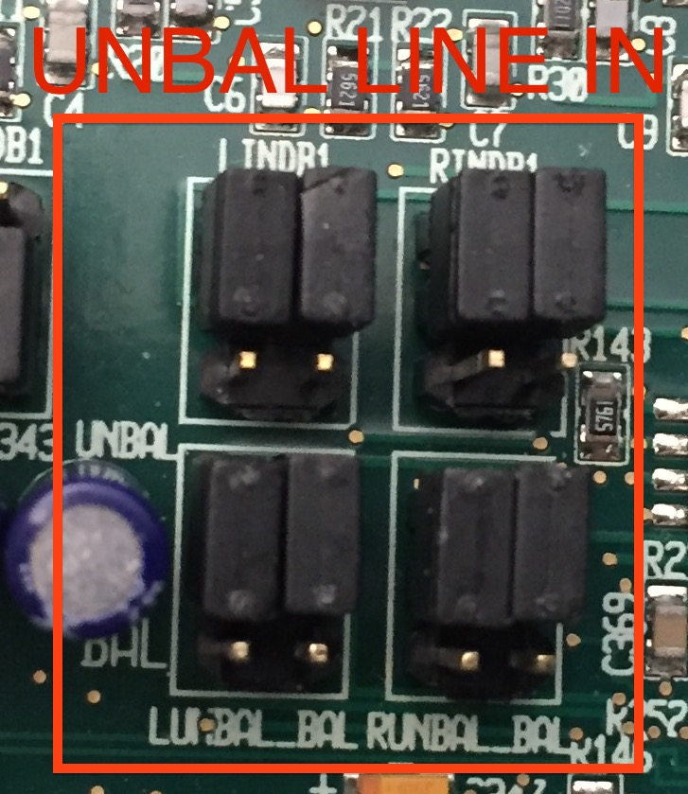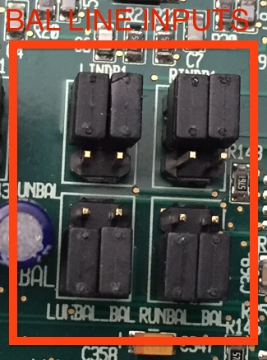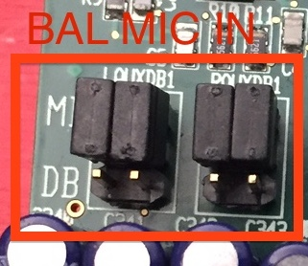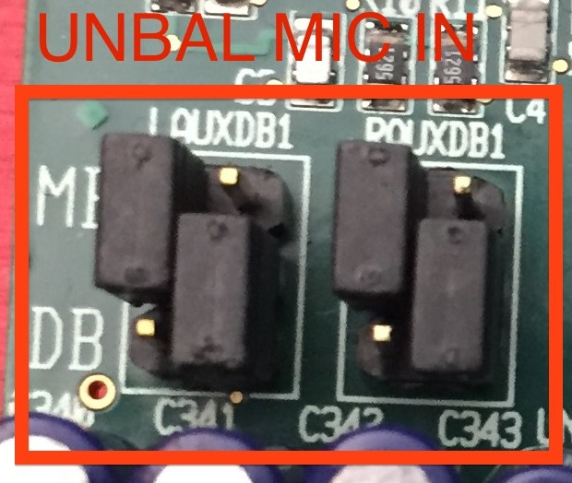

Note about Audio Outputs:
Any or all of rPod audio channels (1-8) can be played in mono or stereo. Audio outputs are designated in the function description in stereo left and right pair format e.g., Channel 1 Left and Channel 1 Right. Since any output can be played monaurally, each output has a mono-referred/software number from 1-8 for the primary channels and 9-12 for the subwoofers. The subwoofer channels are derived from their associated stereo pairs however, do have software control for parameters such as volume and crossover frequency. Channel 9 is the subwoofer for Channels 1 and 2, Channel 10 for Channels 3 and 4, Channel 11 for 5 and 6, and Channel 12 for 7 and 8. The software channel odd numbers from 1-7 designate the left side of a stereo pair and the even numbers designate the right side. Therefore Channels 1,2 would be a stereo pair with 1 being left and 2 being right, etc., up to Channels 7,8 the next with 7 being left and 8 being right.

J2 Audio Output Software Channels 5-8 / Subwoofers 11 and 12
(2) This connector is used to output line level audio signals from stereo channels 3 and 4, mono/software channels 5-8, 11,12. Each output may be connected to a balanced or unbalanced receiver. When connecting to an unbalance receiver, connect the signal to the positive (+) output, float the negative (-) output and ground the audio ground return. Use mono/software channel assignments should be used for all software commands and sequence programming.

J2 Pin | Function | Detail | Software Channel
1T | Line Output #3 Left + | Balanced or Unbalanced | 5
2T | Line Output #3 Left - | Balanced or Unbalanced | 5
3T | Audio Ground | Balanced or Unbalanced | 5
4T | Line Output #4 Left + | Balanced or Unbalanced | 7
5T | Line Output #4 Left - | Balanced or Unbalanced | 7
6T | Audio Ground | Balanced or Unbalanced | 7
7T | Subwoofer Line Output #3 + | Balanced or Unbalanced | 11
8T | Subwoofer Line Output #3 - | Balanced or Unbalanced | 11
9T | Audio Ground | Balanced or Unbalanced | 11
1B | Line Output #3 Right + | Balanced or Unbalanced | 6
2B | Line Output #3 Right - | Balanced or Unbalanced | 6
3B | Audio Ground | Balanced or Unbalanced | 6
4B | Line Output #4 Right + | Balanced or Unbalanced | 8
5B | Line Output #4 Right - | Balanced or Unbalanced | 8
6B | Audio Ground | Balanced or Unbalanced | 8
7B | Subwoofer Line Output #4 + | Balanced or Unbalanced | 12
8B | Subwoofer Line Output #4 - | Balanced or Unbalanced | 12
9B | Audio Ground | Balanced or Unbalanced | 12

J3 Audio Output Software Channels 1-4 / Subwoofers 9 and 10
(3) This connector is used to output line level audio signals from stereo channels 1 and 2, mono/software channels 1-4, 9,10. Each output may be connected to a balanced or unbalanced receiver. When connecting to an unbalance receiver, connect the signal to the positive (+) output, float the negative (-) output and ground the audio ground return. Use mono/software channel assignments should be used for all software commands and sequence programming.

J3 Pin | Function | Detail | Software Channel
1T | Line Output #1 Left + | Balanced or Unbalanced (Float Out -) | 1
2T | Line Output #1 Left - | Balanced or Unbalanced (Float Out -) | 1
3T | Audio Ground | Balanced or Unbalanced (Float Out -) | 1
4T | Line Output #2 Left + | Balanced or Unbalanced (Float Out -) | 3
5T | Line Output #2 Left - | Balanced or Unbalanced (Float Out -) | 3
6T | Audio Ground | Balanced or Unbalanced (Float Out -) | 3
7T | Subwoofer Line Output #1 + | Balanced or Unbalanced (Float Out -) | 9
8T | Subwoofer Line Output #1 - | Balanced or Unbalanced (Float Out -) | 9
9T | Audio Ground | Balanced or Unbalanced (Float Out -) | 9
1B | Line Output #1 Right + | Balanced or Unbalanced (Float Out -) | 2
2B | Line Output #1 Right - | Balanced or Unbalanced (Float Out -) | 2
3B | Audio Ground | Balanced or Unbalanced (Float Out -) | 2
4B | Line Output #2 Right + | Balanced or Unbalanced (Float Out -) | 4
5B | Line Output #2 Right - | Balanced or Unbalanced (Float Out -) | 4
6B | Audio Ground | Balanced or Unbalanced (Float Out -) | 4
7B | Subwoofer Line Output #2 + | Balanced or Unbalanced (Float Out -) | 10
8B | Subwoofer Line Output #2 - | Balanced or Unbalanced (Float Out -) | 10
9B | Audio Ground | Balanced or Unbalanced (Float Out -) | 10

J4 DMX and Serial DTE/RS-485
(4) The J4 connector, located at the rear center edge of the board, has a DMX/RS-485 interface on the top row. For the bottom connector, jumpers can used to set the mode for this interface to be an RS-232 DTE serial port or an auxiliary RS-485 serial interface. The jumper settings (5) for the J4 bottom connector are provided subsequent to the pin function chart below. These functions are listed with the DTE list first and the Aux RS-485 second.

J4 Pin | Function | Detail | Software Channel
1T | DMX RX + | RS-485 Input RX+ | DMX IN
2T | DMX RX - | RS-485 Input RX- | DMX IN
3T | GROUND | Signal Ground | DMX IN
4T | DMX TX+ | RS-485 Output TX+ | DMX OUT
5T | DMX TX- | RS-485 Output TX- | DMX OUT
6T | GROUND | Signal Ground | DMX OUT
1B | Unused/AUX RS485 RX+ | Unused/RS-485 Input RX+ | DTE
2B | DTERX/AUX RS485 RX- | Receive Input/RS-485 Input RX- | DTE
3B | DTETX/RS-485 GND | Transmit Output/Gnd | DTE
4B | DTECTS/AUX RS485 TX+ | Clear to Send Handshake Input/RS-485 Output TX+ | DTE
5B | GROUND/AUX RS485 TX- | Signal Ground/RS-485 Output TX- | DTE
6B | DTERTS/RS-485 GND | Request to Send Handshake Output/Gnd | DTE

The DMX interface provides independent transmit and receive channels. It supports the full IEEE standard DMX protocol operating at 250Kbaud, 8bits, 2 stop bits and no parity. DMX-512 is an RS-485 (serial communication) lighting standard. The rPOD uses this standard not only for lighting, but also control expansion (as is used in character animation control), and for optional communication between rPODs. The channel update rate is fixed at 30 frames per second, providing full compatibility with SLAM-2000 and generation one and two Mini-Sam II control files. The balanced output impedance of the transmitter is typically 100 ohms. When connecting to DMX equipment, use a controlled impedance cable of 100 ohms (maximum of 120 ohms). You can daisy chain multiple units of DMX equipment (connecting in parallel) however, at the end of the chain a 1/2W 100 ohm (or 120 ohm for 120 ohm cable) should be placed across the “+” and “–” terminals of the last device. For converting DMX data into 16-bits of discrete control over two DMX channels for applications such as animatronics control, the SKE Model DMX16-DO is recommended. This interface can be used to program DMX information into the rPOD using the Recdmx command. The DMX interface can be controlled using three different methods:

- Direct commands entered through the Console or DTE serial ports. This includes discrete bit control (Dmx command), channel value setting (Dmx command) and channel ramping (Dimto command)
- Control file playback using the Lddmx, Playdmx, Loopdmx, Mount, Stopdmx, Start, Posdmx, and Skipdmx commands.
- Sequence program control. Programs can initiate both direct control and control file playback.

The DTE interface is an RS-232 Serial Port providing a PC style COM port. Like the Console port, this port can be accessed for rPod control, configuration, status and sequence program initiation. Its primary function is to control other RS-232 devices. This port has provisions for hardware handshaking but is not currently implemented in software. It can be connected to a standard PC and controlled using a standard terminal program such as HyperTerminal. The default port configuration is 115 kbaud, 8 bits, 1 stop bit, no parity, and no handshaking. The port configuration can be changed through the command interface or sequence programming using the Config DTE command. The alternate configuration for RS485 serial can also be programmed for different baud rates and settings. More on this can be found in the SKE Software Description Manual.

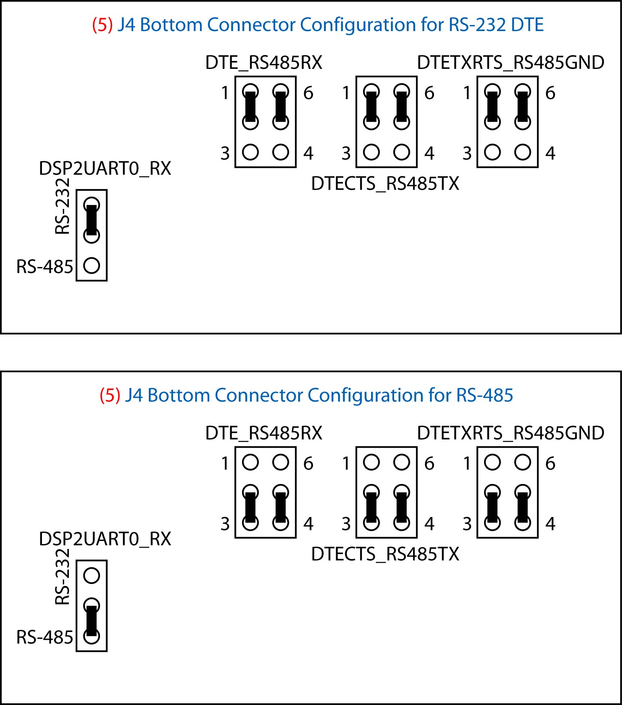

J5 Input/Output Connector
(6) This connector, located on the rear edge between J4 and J6, is used for input triggering on the top row of pins and eight discrete control outputs on the bottom row of pins. The control outputs are mapped to DMX channel 1 and can be controlled in software through the various DMX commands. Trigger input status can be accessed in software using the Trign, Closen, Openn, and Inputs system variables where n is the trigger number. The connection pin out is provided below.

J5 Pin | Function | Detail
1T | Common for Trigger Inputs 1-8.  (See Note 1) | Common of Opto-Isolator return for Triggers 1-8. (See Note 1)
2T | Input 1-4 Pull-up/down Voltage.  (See Note 2) | Use for “HIGH-SIDE” or “LOW-SIDE” Triggering.  (See Note 2)
3T | TRIGGER 1 | Opto-iso. digital input #1. (See Note 3)
4T | TRIGGER 2 | Opto-iso. digital input #2. (See Note 3)
5T | TRIGGER 3 | Opto-iso. digital input #3.(See Note 3)
6T | TRIGGER 4 | Opto-iso. digital input #4.(See Note 3)
7T | TRIGGER 5 | Opto-iso. digital input #5.(See Note 3)
8T | TRIGGER 6 | Opto-iso. digital input #6.(See Note 3)
9T | TRIGGER 7 | Opto-iso. digital input #7.(See Note 3)
10T | TRIGGER 8 | Opto-iso. digital input #7.(See Note 3)
11T | INPUTS 5-8 PULLUP VOLTAGE.  (See Note 2) | Use for “HIGH-SIDE” or “LOW-SIDE” Triggering.  (See Note 2)
12T | Common for Trigger Inputs 1-8.  (See Note 1) | Common of Opto-Isolator return for Triggers 1-8. (See Note 1)
1B | CTL1-4RTN. (See Note 4) | Common bus for outputs 1-4.
2B | Control Output Pull-up Voltage.  (See Note 5) | DC Power for load. Current limited to 1 AMP also serving pin 11B.
3B | CONTROL OUT 1 | COLLECTOR OF OPTO ISOLATED OUTPUT #1
4B | CONTROL OUT 2 | COLLECTOR OF OPTO ISOLATED OUTPUT #2
5B | CONTROL OUT 3 | COLLECTOR OF OPTO ISOLATED OUTPUT #3
6B | CONTROL OUT 4 | COLLECTOR OF OPTO ISOLATED OUTPUT #4
7B | CONTROL OUT 5 | COLLECTOR OF OPTO ISOLATED OUTPUT #5
8B | CONTROL OUT 6 | COLLECTOR OF OPTO ISOLATED OUTPUT #6
9B | CONTROL OUT 7 | COLLECTOR OF OPTO ISOLATED OUTPUT #7
10B | CONTROL OUT 8 | COLLECTOR OF OPTO ISOLATED OUTPUT #8
11B | Control Output Pull-up Voltage.  (See Note 5) | DC Power for load. Current limited to 1 AMP also serving pin 2B.
12B | CTL5-8RTN. (See Note 4) | Common bus for outputs 5-8.

Note 1: Typically connected to rPod GROUND via GNDJP1 or left open to connect to for and isolated return to external source for Trigger Power.
Note 2: TRGPWR1-4 selects +DC input power from the rPOD (jumper pins 1-6), internal 5V regulated rPOD Power (jumper pins 2-5) for "LOW-SIDE" triggering or, GND (jumper pins 3-4) for "HIGH-SIDE" triggering. By removing these jumpers you can provide an external isolated voltage and by drive the input (e.g., pin 3 for Trigger 1) high or low with pin 2 being connected to the external supply (for "LOW-SIDE" triggering) or the external supply return for "HIGH-SIDE" triggering. This same logic applies for TRGPWR5-8. Pins 2T and 11T (pullup/down voltages) are current limited with a PTC rated at 0.2AMP for protection.
Note 3: These pins may be driven high or low for "HIGH-SIDE" (PULL-UP) or "LOW-SIDE" (PULL-DOWN) triggering based on the settings of the TRGPWR1-4 and TRGPWR5-8 jumpers.
Note 4: This pin can be connected to the rPOD DC INPUT POWER GND, internal 5V Digital Power GND, or left open via CTL1-4RTN or CTL5-8RTN for connecting to an external isolated ground.
Note 5: CTLPWR1 selects the +DC input power from the rPOD, internal 5V regulated rPOD power, or EXT INPUT (leave open) via this connector pin. A 1A PTC resetable fuse isolates this power from the power pins 2B and 11B.

Trigger Inputs: The following is a circuit diagram of Trigger 1 configured as a non-isolated low side trigger. The circuits in GREEN are common to all triggers. The circuits in RED are common to Triggers 1-4:

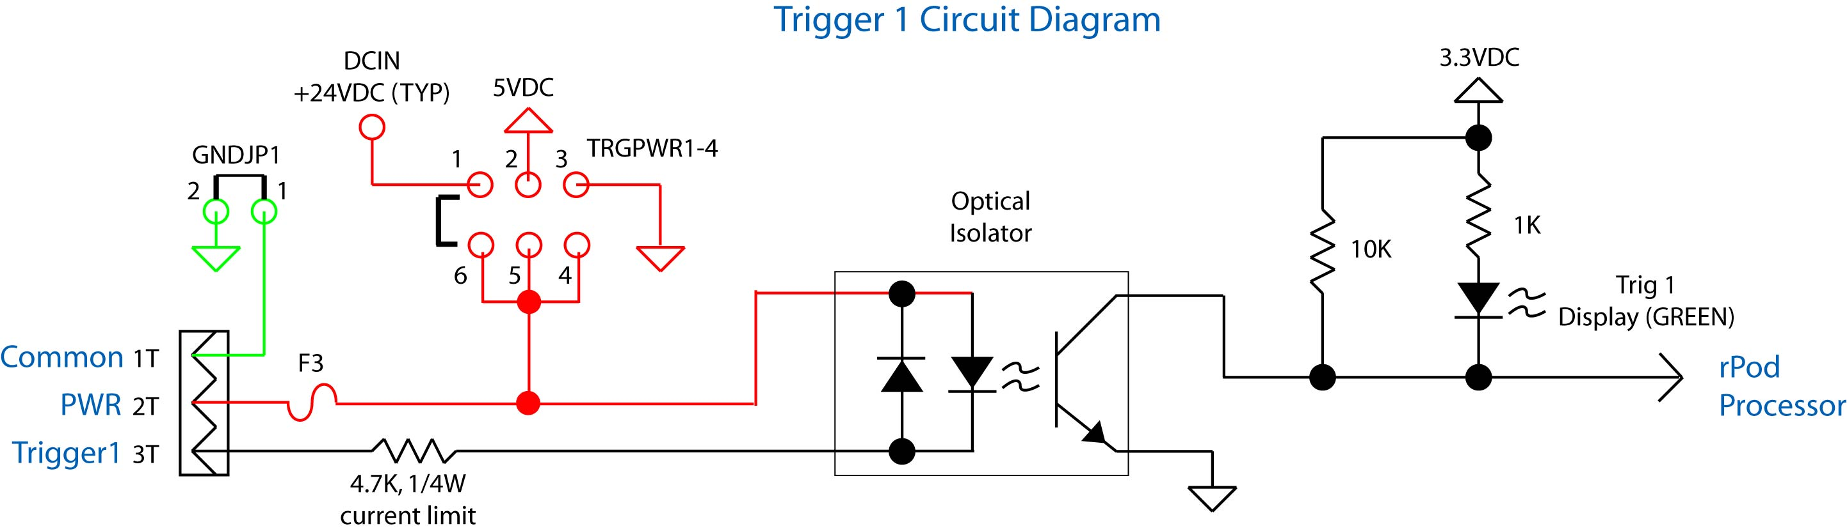

(7) GND JP1: It is a two pin jumper that, when installed, connects the system ground to pins J5-1T and J5-12T (non-isolated).

(14) TRG1-4PWR, (15) TRG5-8PWR: These jumpers select the voltage supplied to the isolator. It may be set to Input DC (+24V), 5 VDC, GND, or left open for use with an external isolated supply. The configuration options are shown below. TRG1-4PWR and TRG5-8PWR can be set autonomously from eachother.

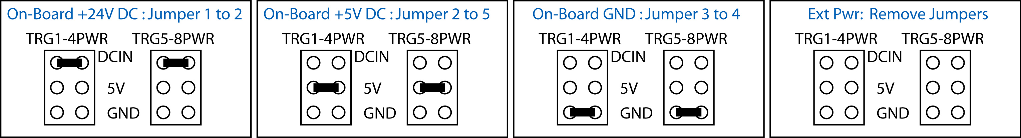

External Power Setting: To use an isolated power source (recommend 5 to 24VDC), remove the (14) TRG1-4PWR and/or (15) TRG5-8PWR (7) and/or GNDJP1 jumpers. Connect an external power supply to pin J5-2T/J5-11T and the supply ground to J5-1T/J5-12T. If isolated high side triggering is used, a valid Vpullup voltage activates the trigger inputs. Each input has a series limiting resistor of 4.7KΩ 1/4W and the typical isolator diode Vf = 1.15V. The current in the diode is:

Idiode (mA) = (Vpullup – 1.15)/4.7

Vpullup should be selected such that the current is always between 1 to 5mA.

Control Outputs: The following is a circuit diagram of CTLOUT 1. The circuits in RED are common to all outputs:

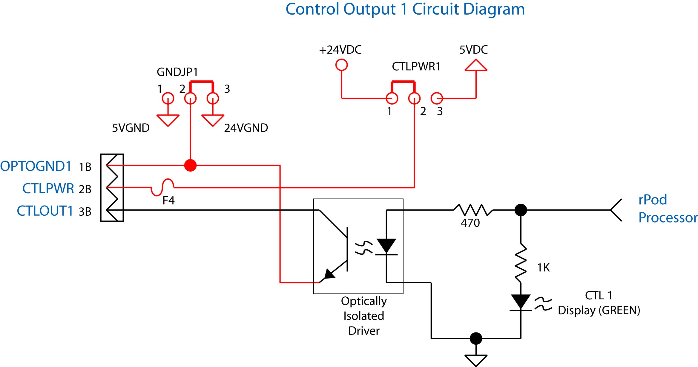

Each of the eight outputs are open-collector low-side drivers capable of 50mA (typical) sink current per driver. Higher currents at lower duty cycles are possible so long as maximum current and power specifications of the TCED4100 driver are not exceeded (consult the Toshiba datasheet). The common pullup voltage is jumper programmable via (11) CTLPWR1.

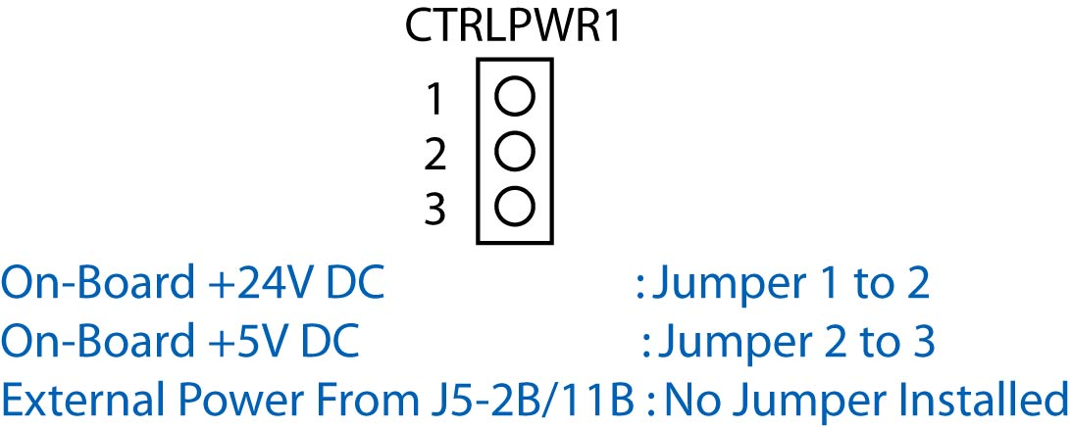

Jumper from the center pin to the 24V pin for 24V relays, valves and other loads, or 5V for 5V loads. Note that the 24V setting for all jumpers is actually the DC input power voltage. Therefore if another e.g., 12V power source is used, that will be the voltage at the 24V jumper positions.

The common low-side return is jumper programmable via CTL1-4RTN (12) and CTL5-8RTN (13). These jumpers select either the +24V DC ground or the +5V DC ground. The jumpers should be installed in the opposite position as the (11) CTRLPWR1 jumper.

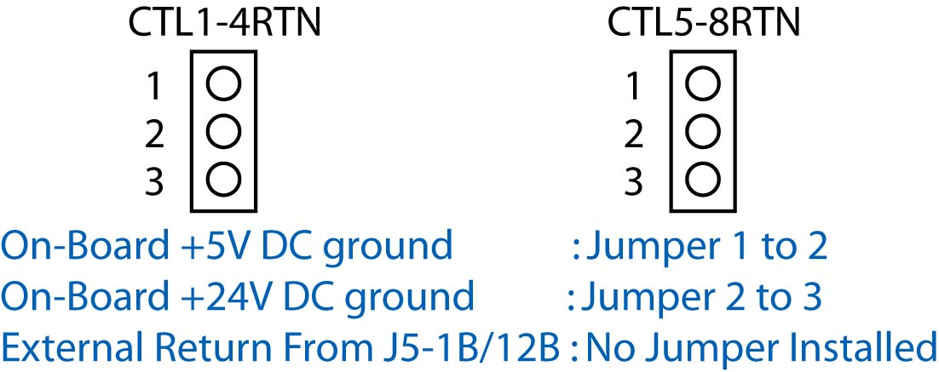

IMPORTANT: FOR INDUCTIVE LOADS SUCH AS SOLENOIDS, ALWAYS MAKE SURE THE LOAD HAS FLYBACK DIODE MOUNTED AT OR IN THE LOAD TO PREVENT INDUCTIVE KICK DAMAGE TO THE LOAD AND rPOD DRIVER CHIPS. NEVER SHORT ANY CONTOL OUTPUT DIRECTLY TO GROUND AS THIS WILL MOST LIKELY DAMAGE THE DRIVER.

J6 DC Power Supply Input
(8) This connector is located on the rear edge of the board toward the right side. It is the main power supply input and must be connected to a 10-30 Volt minimum 2 Amp regulated power supply. The Simon-Kaloi Engineering PS-24V Power Supply is recommended. The power supply should be sized larger for larger loads. For example, if you require 2 amps for the total control loads use a minimum 4 Amp supply.

J6 Pin | Function | Detail
1T | POSITIVE DC IN | 10-30VDC RANGE
1B | POSITIVE DC IN | 10-30VDC RANGE
2T | DC COMMON IN | POWER SUPPLY RETURN
2B | DC COMMON IN | POWER SUPPLY RETURN
3T | CHASSIS GROUND
3B | CHASSIS GROUND

Power Switch Jumper
The Power Switch Jumper (9) is installed in lieu of a power switch and allows the rPOD to power on/off directly from the power supply without the need for a power switch.

Power Switch Interface
The Power Switch Interface Connector (10) allows a power switch to be implemented. To use a power switch connect a SPST to the PWRSWIF1 (10) connector using the Phoenix Contact #1803578. Polarity is not an issue. You must remove the Power Switch Jumper (9) in order to make the power switch active.

Boot Jumpers
BOOT1 (16) jumper and BOOT2 (17) jumpers are available as a secondary method for loading new Operating System (OS) revisions into the rPOD. For more on this, please see the “Loading A New Operating System” of this manual.

Real-Time Clock Backup Battery
(18) The rPOD has a real-time clock circuit that keeps track of the actual time. This is useful for example when timed event triggering is desired. The rPOD uses a 3 Volt 2032 style backup battery to maintain the clock when power is removed. This battery has a long life and can last several years. The battery is only used when rPOD is not powered therefore the battery life can vary depending on powered use. When this battery measures less than 2.7 Volts it should be replaced.

RASR and Auxilary Interface
(19) The rPOD has a RASR/Auxilary Interface for connecting to the RASR-1 Board (shown below). This board always features an additional (to the rPOD’s on-board) MIDI interface, a SMPTE transceiver, and an ADAT optical receiver interface for programming. Typically this board is mounted to the r-POD for programming using three 1” standoffs and plugging the RASR interface connectors together. After programming the RASR-1 is typically removed however, it can be left mounted for other options such as SMPTE syncing applications. This interface can also be used as an alternate interfaces for other devices such as displays, and keyboards. The pin function is shown below the picture of the RASR board.

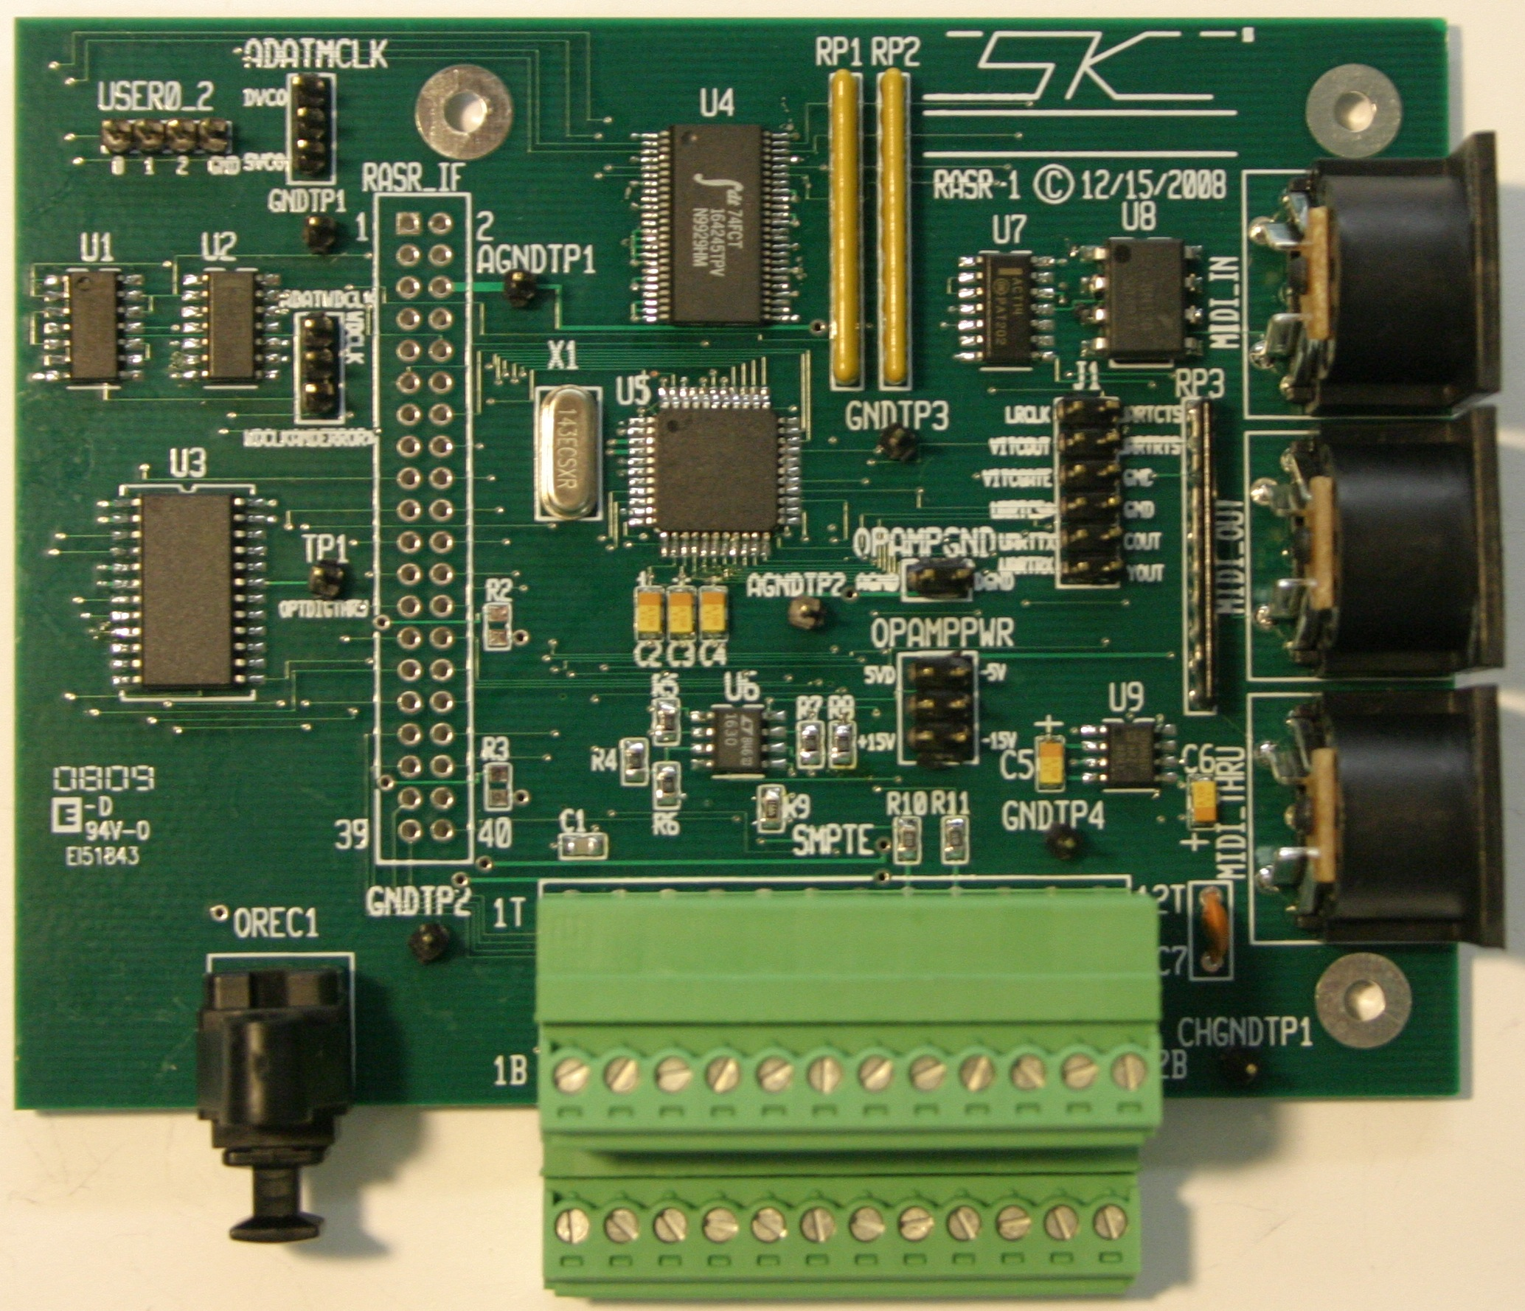

RASR I/F Pin | Description/Function
1 | RASR SENSE* (Signal goes low when RASR-1 board is plugged in).
2 | Chassis Gnd from rPOD to RASR.
3 | 3.3V Digital Power from rPOD to RASR.
4 | +15V Analog Power from rPOD to RASR.
5 | Digital Gnd from rPOD to RASR.
6 | Analog Gnd from rPOD to RASR.
7 | Digital Gnd from rPOD to RASR.
8 | -15V Analog Power from rPOD to RASR.
9 | 5V Digital Power from rPOD to RASR.
10 | 5VA3 (Address Line from rPOD to RASR).
11 | SMPTEINTR (SMPTE Transceiver Interrupt Pin).
12 | 5VOE* (Output Enable Line from rPOD to RASR).
13 | Digital Gnd from rPOD to RASR.
14 | 5VD0 (Digital Data bus between rPOD and RASR).
15 | 5V Digital Power from rPOD to RASR.
16 | 5VD1 (Digital Data bus between rPOD and RASR).
17 | ADATDATA1_2 (Decoded ADAT Audio Data Channels 1 and 2).
18 | 5VD2 (Digital Data bus between rPOD and RASR).
19 | ADATDATA3_4 (Decoded ADAT Audio Data Channels 3 and 4).
20 | 5VD3 (Digital Data bus between rPOD and RASR).
21 | ADATDATA5_6 (Decoded ADAT Audio Data Channels 5 and 6).
22 | 5VD4 (Digital Data bus between rPOD and RASR).
23 | ADATDATA7_8 (Decoded ADAT Audio Data Channels 7 and 8).
24 | 5VD5 (Digital Data bus between rPOD and RASR).
25
26 | 5VD6 (Digital Data bus between rPOD and RASR).
27
28 | 5VD7 (Digital Data bus between rPOD and RASR).
29
30 | 5VA1 (Address Line from rPOD to RASR).
31
32 | 5VA2 (Address Line from rPOD to RASR).
33
34 | 5VARE* (Receive Enable Line from rPOD to RASR).
35
36 | 5VAWE* (Write Enable Line from rPOD to RASR).
37
38 | 5VEXTDATACE* (External Data Chip Enable Line from rPOD to RASR).
39
40 | 5VRESET(Reset Line from rPOD to RASR).

Run/Stop Switch and Interface
The RUN/STOP Switch (21) is a hardware method to stop user scripts from running and start them again. When a script is running pressing this button will halt the script. Pressing it again will resume it. This allows users to break the script as well as perform diagnostics. For example, using a host computer and terminal program you can stop a script and then step through it will the STEP command. A RUN/STOP I/F is also provided to allow connections to a remote SPST switch.

Status Display
(23), (24), (26) The Status displays indicate the current state of the system including triggers, control outputs, CF card insertion, and faults. When the display is illuminated, assertion of the function is indicated. For the fault indicators, Module 8, an illuminated display indicates no fault exists. A picture of the status LEDs.The diagram and table below show the indicator assignments:

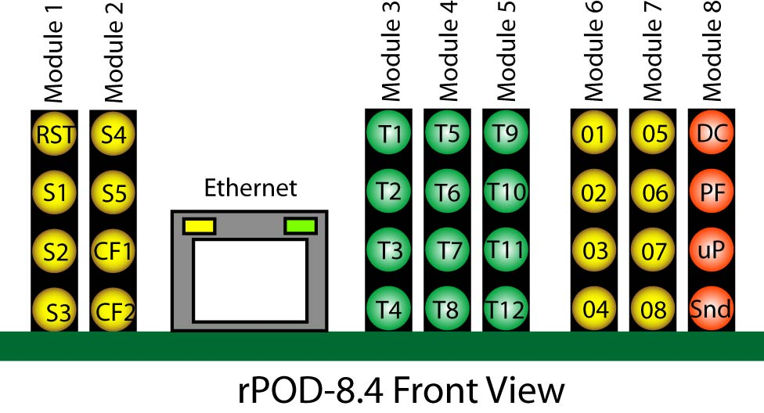

Module 1 | Function | Module 2 | Function
RST | Reset | S4 | Status 4
S1 | Status 1 | S5 | Status 5
S2 | Status 2 | CF1 | CF Card 1 inserted (solid), out (blinks)
S3 | Status 3 | CF2 | CF Card 2 inserted (solid), out (blinks)
Module 3 | Function | Module 4 | Function
T1 | Trigger 1 | T5 | Trigger 5
T2 | Trigger 2 | T6 | Trigger 6
T3 | Trigger 3 | T7 | Trigger 7
T4 | Trigger 4 | T8 | Trigger 8
Module 5 | Function | Module 6 | Function
T9 | Trigger 9 | 01 | Control Out 1
T10 | Trigger 10 | 02 | Control Out 2
T11 | Trigger 11 | 03 | Control Out 3
T12 | Trigger 12 | 04 | Control Out 4
Module 7 | Function | Module 8 | Function
05 | Control Out 5 | DC | DC Power OK (From triple comparator)
06 | Control Out 6 | PF | Power Fail OK (from Supervisory IC)
07 | Control Out 7 | uP | Processor OK
08 | Control Out 8 | Snd | Audio OK

Ethernet Interface and Jumpers

(20) Reserved for SKE use only.

J12 and J13 Compact Flash Connectors
(28), (27) The rPod uses compact flash memory to store and stream audio and control data. Compact flash facilitates fast transfer rates in a solid-state media and therefore allows the rPod to exhibit features and functionality that put it in a class by itself. This interface allows compact flash cards (not provided) of various sizes to be used with the rPod. By using a standard PC and card writer, files can be dragged and dropped as well as removed from the CF card. The cards should be sized for the maximum number of files required. For 16-bit 44.1Khz mono files about 5MB per minute of total audio is required (10MB for stereo files). High-performance cards such as the Extreme III by Sandisk are recommended for optimum performance.

The rPod will function with one, two, or no cards installed. Cards may be inserted and removed with or without power applied provided there is no write activity in progress. Cards installed in the J12 connector are referenced by software as the “a” drive and cards in the J13 connector as the “b” drive.

J11 MIDI/Aux Serial Interface
(29) This connector provides a standard MIDI interface or Aux Serial Port. The mode selection is achieved via (35) MIDI/AUX SR jumpers.
J11 Pin | MIDI Function | AUX SERIAL Function
1 | MIDI IN + | DO NOT USE
2 | MIDI IN - | RXD
3 | MIDI THRU + | TXD
4 | MIDI THRU - | DO NOT USE
5 | MIDI OUT + | GND
6 | MIDI OUT - | DO NOT USE

Console Serial Port (DCE)
(30) The Console interface is a standard 9-PIN Sub-miniature female connector located at the front left edge of the board. The interface is an RS-232 Serial Port providing a DCE style COM port. Like the DTE port, this port provides for rPod control, configuration, status and sequence program initiation. Its primary function is as a command and programming interface. This port has no provisions for hardware handshaking. It can be connected to a standard PC and controlled using a standard terminal program such as HyperTerminal. The default port configuration is 115 kbaud, 8 bits, 1 stop bit, no parity, no handshaking. The port configuration can be changed through the command interface or sequence programming using the Config Console command.

DCE Pin | Function | Detail | Software Channel
1 | DTR | NON CONNECTED | -
2 | TXD | ACTIVE PIN | Console
3 | RXD | ACTIVE PIN | Console
4 | CD | NON CONNECTED | -
5 | GROUND | ACTIVE PIN | Console
6 | N/C | - | -
7 | N/C | - | -
8 | N/C | - | -
9 | RI | NON CONNECTED | -
CASE | CHASSIS GROUND | ACTIVE PIN | Console

J8 Auxiliary Triggers and Fault Control Status
(34) This connector, located on the left side towards the front, is used for input triggering on the top row of pins and four discreet status control outputs on the bottom row of pins. Trigger input status can be accessed in software using the Trign, Closen, Openn, and Inputs system variables where n is the trigger number. The connection pin out is provided below. Use the Control Output 1 circuit diagram as a reference for the Fault output interface.

J8 Pin | Function | Detail
1T | Common for Trigger Inputs 9-12.  (See Note 1) | Common of Opto-Isolator return for Triggers 9-12. (See Note 1)
2T | Input 9-12 Pull-up/down Voltage.  (See Note 2) | Use for “HIGH-SIDE” or “LOW-SIDE” Triggering.  (See Note 2)
3T | TRIGGER 9 | Opto-iso. digital input #9.(See Note 3)
4T | TRIGGER 10 | Opto-iso. digital input #10.(See Note 3)
5T | TRIGGER 11 | Opto-iso. digital input #11.(See Note 3)
6T | TRIGGER 12 | Opto-iso. digital input #12.(See Note 3)
7T | Input 9-12 Pull-up Voltage.  (See Note 2) | Use for “HIGH-SIDE” Triggering.  (See Note 3)
8T | Common for Trigger Inputs 9-12.  (See Note 1) | Common of Opto-Isolator return for Triggers 9-12. (See Note 1)
1B | CTL9-12RTN. (See Note 4) | Common bus for outputs 9-12.
2B | Control Output Pull-up Voltage.  (See Note 5) | DC Power for load. Current limited to 1 AMP also serving pin 7B.
3B | DC OK | CTLOUT9
4B | POWER FAIL OK | CTLOUT10
5B | PROCESSOR OK | CTLOUT11
6B | AUDIO OK | CTLOUT12
7B | Control Output Pull-up Voltage.  (See Note 5) | DC Power for load. Current limited to 1 AMP also serving pin 2B.
8B | OPTOGND3. (See Note 5) | Common bus for outputs 9-12.

Note 1: Typically connected to rPod GROUND via GNDJP2 (33) or left open to connect to for and isolated return to external source for Trigger Power.
Note 2: TRGPWR9-12 (36) selects +DC input power from the rPOD (jumper pins 1-6), internal 5V regulated rPOD Power (jumper pins 2-5) for "LOW-SIDE" triggering or, GND (jumper pins 3-4) for "HIGH-SIDE" triggering. By removing these jumpers you can provide an external isolated voltage and by drive the input (e.g., pin 3 for Trigger 9) high or low with pin 2 being connected to the external supply (for "LOW-SIDE" triggering) or the external supply return for "HIGH-SIDE" triggering. Pins 2T and 7T (pullup/down voltages) are current limited with a PTC rated at 0.2AMP for protection. The configuration for the jumpers works the same as TRGPWR1-4.
Note 3: This pin may be set for "HIGH-SIDE" (PULL-UP) or "LOW-SIDE"(PULL-DOWN) triggering through the TRGPWR9-12 (36) jumpers.
Note 4: This pin can be connected to the rPOD DC INPUT POWER GND, 5VGND, or left open via CTL9-12RTN (32) for connecting to an external isolated ground. The configuration for the jumpers works the same as CTL1-4RTN.
Note 5: CTLPWR2 (31) selects the +DC input power from the rPOD, internal 5V regulated rPOD power, or EXT INPUT (leave open) via this connector pin. A 1A PTC resetable fuse isolates this power from the power pins 2B and 7B. The configuration for the jumpers works the same as CTLPWR1.

MIDI/AUXSR & Ext Reset
(35) The Ext Reset Header (EXTRES1), is a reserved feature and should not be used without consulting SKE. The MIDI/AUX SR1 Jumpers select the mode of the MIDI/AuxSR Interface (29).

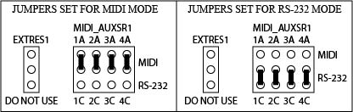
External Clock Interface
(37) The External Clock Interface Connector and XMITCLK (40) and LOC_EXTCLK (42) jumpers permit syncing the audio clock source with one unit as a master and others as slaves. This facilitates clock and frame sync accuracy between rPODs. A block diagram for this circuit is shown below. The default setting is with both jumpers set for internal on-board synth clock, each being jumpered pins 1-2. Use these same settings to set an r-POD up to be a master and connect the TX+, TX-, and GND of the EXTCLK connector of the master to the RX+, RX-, and GND EXTCLK connector of the first slave. Use twisted shielded pair cable with a differential impedance of 100 ohms. You can connect additional slaves in the same manner by connecting TX lines and GND from Slave 2 to RX and GND of Slave 3, and so on for subsequent units. For a slave, move both the XMITCLK (40) and LOC_EXTCLK (42) jumpers to pins 2-3 the EXT setting.

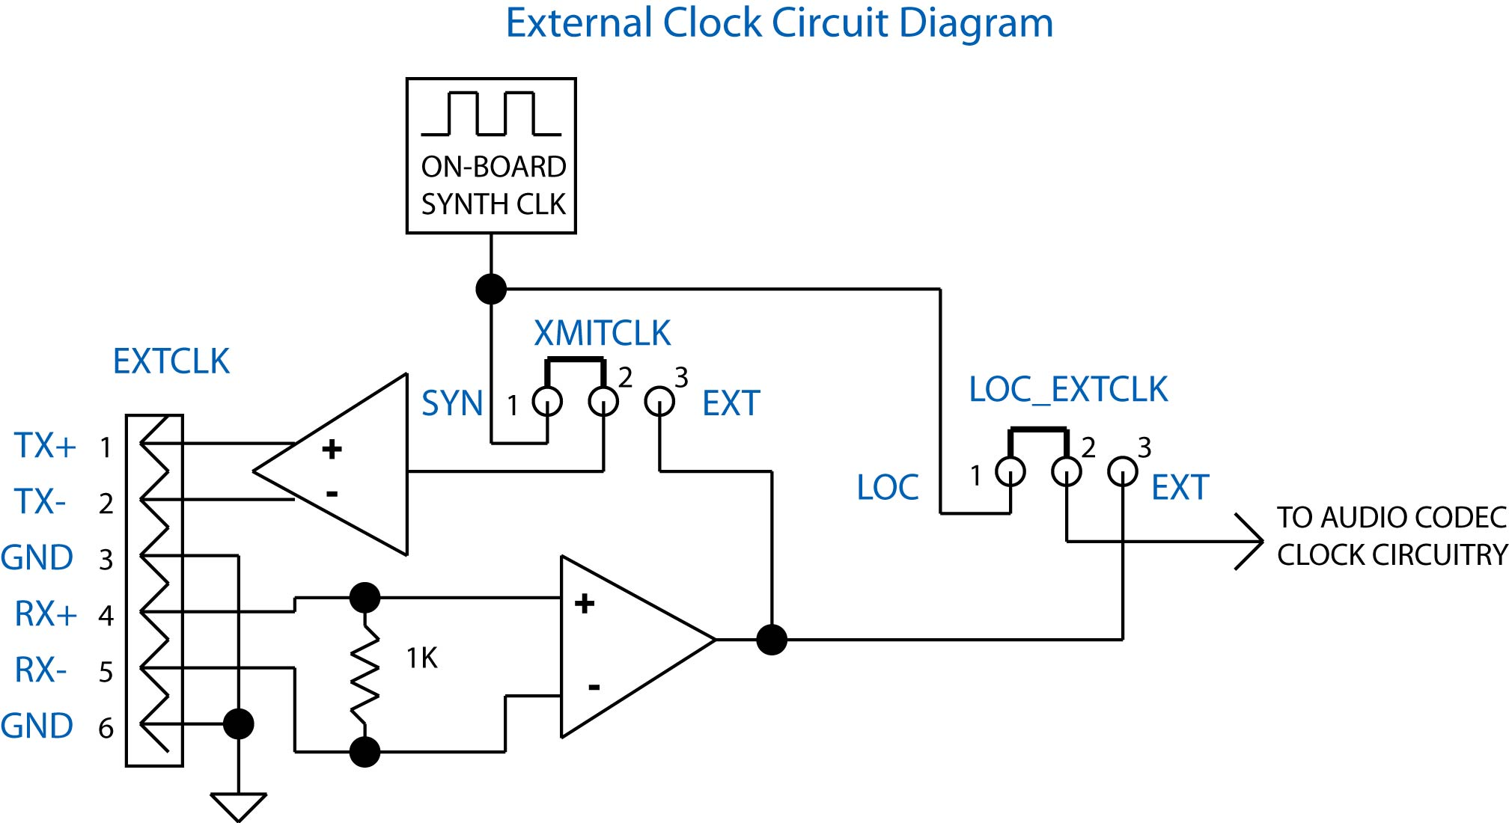

Reset Switch
(38) The Reset Switch restarts the rPOD. This switch does essentially the same function as powering down and powering up the unit. Wait about 7 seconds after pressing reset before doing any functions.

AuxDSP Control Jumpers
(39) These jumpers allow each CODEC’s DSP (that performs, filtering, equalization and other functions) to be programmed using the Analog Devices tools and their Sigma Studio software. Contact SKE for more information on this.

CODEC Control Jumpers
(43) These jumpers allow each CODEC’s DSP (that performs, filtering, equalization and other functions) to be programmed using the Analog Devices tools and their Sigma Studio software. Contact SKE for more information on this.

Software
This section covers some of the basic concepts and fundamentals for using the rPOD software and programming system. For more information on programming, refer to the “rPod and MS-II Software Description” manual.

Files
The rPOD adheres to the FAT32 file system that is recognized by Windows and Macintosh Computers. For best performance high-quality Compact Flash cards such as the Extreme III and Extreme IV series from Sandisk are highly recommened. To load files onto a compact flash card you will need a computer with an internal or external compact flash drive. Simply insert the card into the drive and you should be able to view, add, move, and delete files by dragging and dropping as you would with any other drive. Once your CD card has the desired files, remove the card from the computer drive and insert it into the rPOD for use. There are four types of files that are recognized by the rPOD. Each of these is described below.

- Sound Files – These files are the audio message and music files.
- Control Files – These are the DMX output control files.
- Configuration Files – A set of application, mapping, and parameter files that are used to define the configuration of the two slave Digital Signal Processors (DSP1 and DSP2) for audio output channels 1 – 4 and the subwoofer channels 11 and 12. This includes the settings for equalization, crossover filtering, dynamics and spatial processing.
- Sequence Program Files – These programs are small text files that adhere to the Sequence programming language and provide full customization of the rPod for your applications. The language turns the rPod into a full-featured programmable logic controller that allows for advanced triggering, branching, logic, timers, and serial communication control.

Sound Files

The rPod uses standard RIFF WAVE formatted sound files. Files names and must have a “.wav” extension. The rPod handles most all internal data with either 28 or 32 bit precision and is capable of processing up to 24bit/48Khz data. Currently, the standard rPod software accepts only 16bit PCM WAVE files sampled at either 44.1 or 48 Khz. The WAVE files can be either signed mono or stereo files. Consult SKE for more information on the preperation, creation, or conversion of sound files for your application.

There are two methods for playing back sound files on the rPod:

The first one is the stereo method using the “Play” command. When using this mode, files are played on stereo pairs. These pairs are {1, 2}, {3, 4}, {5, 6}, {7, 8}, and subwoofers {9, 10, 11, 12}. When playing stereo files, left data is routed to the first channel in the pair and right data to the second channel. Mono file data is played on both channels of the pair.

The second one is monoral using the “Playm” command. Files are only played back on the channel specified. If a stereo file is used, only the left data is routed to the channel specified and the right data is ignored.

Control Files
Control files are created and managed using the software programming tools developed be SKE. These include the “Programmer”, “DMXEdit”, and the built-in DMX capture commands “Ldrecdmx” and “Recdmx”. A description for using the “Programmer” and “DMXEdit” software is provided later on in this manual. The DMX capture commands are described in the “rPod and MS-II Software Description Manual”.

Control files that were created for use with the SLAM 8M and first and second generation MS-II are fully compatible with the rPod and may be used without any conversion or upgrade. Control file names, like sound file names, must have a “.wav” extension.

A single file can contain one or more embedded channels of data. The rPod uses a fixed DMX frame of 30 Frames/second with up to 63 channels.

Programmer
The Programmer is a tool for creating and editing control files. It is primarily intended for discrete control programming e.g., character animation.

Hardware Setup:
Make sure that there is a connection between the PCs serial port and the rPod’s console port using a standard 9-pin male to 9-pin female serial cable. Launch the SKE Programmer and select the appropriate Serial Port. Connect all output control cables and control hardware to the rPOD and then power up the system.

Channel Configuration:
The diagram below describes the Programmer interface controls.

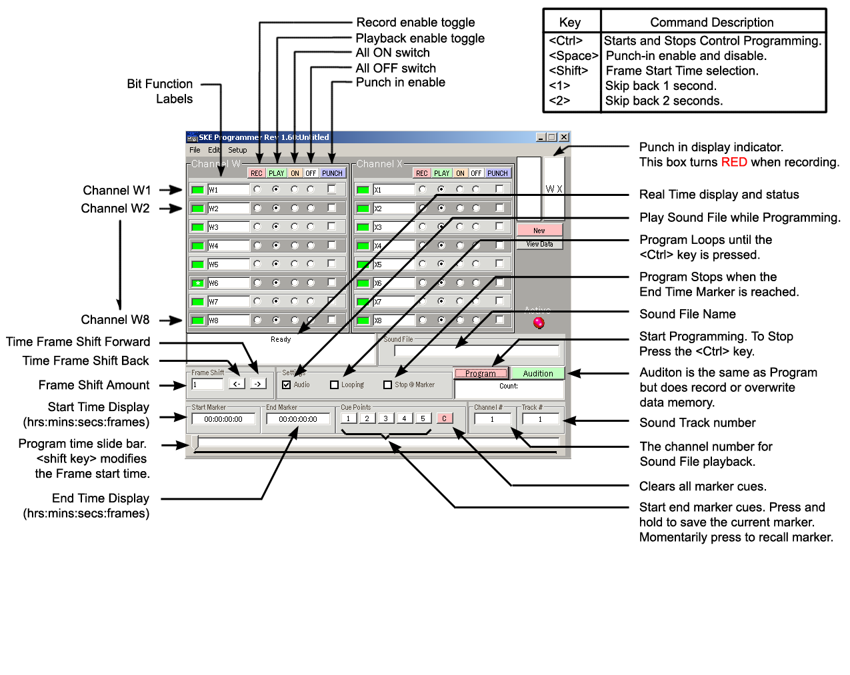
First, select the rPOD Setting in the Programmer setup menu.

You can work with up to two 8-bit Channels (CHW and CHX). When programming, the address for W and X are DMX channels 1and 2 respectively.

The Programmer records four eight-bit channels in groups of two channels. The large WX button toggles between the WX and YZ Channel groups.
For each bit there are four option radio buttons:
- REC – Sets this bit to the record mode.
- PLAY – Sets this bit to the playback mode.
- ON – Turns the bit on (active low). Useful for manual testing of the control bit.
- OFF – Turns the bit off (active high).

Next, select the mode radio buttons, for each bit of the two channels. You can use the buttons above each category to select the mode for all 8 bits of the entire channel.

If programming will be synchronized with audio then select the “Audio” checkbox. Otherwise, un-check this box. To set the audio message that will be played during control programming, type the sound file name into the “sound file” textbox and the audio channel number into the “Ch#” text box. For the rPod, this can be any channel from 1-10.

Either the keyboard or Joystick may be used to toggles the control bits. The default keyboard to bit assignment is shown in the following table.

Channel W  Bit Number | Keyboard  Assignment | Channel X  Bit Number | Keyboard  Assignment
1  2  3  4  5  6  7  8 | A  S  D  F  J  K  L  ; | 1  2  3  4  5  6  7  8 | Q  W  E  R  U  I  O  P

The assignments may be changed using the assign key map window. This window is opened by selecting “Assign Key Map..” in the “Edit” menu.

Finally, The “PUNCH” checkbox configures the bit for punch-in record mode. After control programming has started, use the <Shift> key to toggle between Play (punch out) and Record (punch in) modes. After recording has stopped, either by hitting the <Ctrl> key or when the end of the sound file is reached, all punch-in channels will be set to the Play mode.

Control Recording:
To begin a control record, either click on the program button or press the computer keyboard <CTRL> key. This key starts and stops the process.

When you are in the process of a control record, the number of frames is displayed in the status window. You can edit the control information any number of times before saving your file.

NOTE: If you hear blips in the audio while performing the control recording, do not worry. This is most likely due to the slower computer’s (generally under 400MHz), inability to keep up with the communication rate. When you playback your final program however, you will see that the audio is clean.

You can also use the slider bar to set a start and end point (use the mouse and SHIFT key to select the range). This allows you to control record small segments without having to playback the entire message. You can also type the frame value into the “Start Marker” and “End Marker” boxes. Selecting the “Stop @ Marker” checkbox will cause programming to automatically stop at the end marker. Selecting the “Looping” checkbox will continuously loop the selected range until programming is stopped using the <Ctrl>key.

A “Frame Shift” function shifts the selected range and control bits that have the “Punch” check box selected. Type the number of frames to shift in the shift frame text box. Then select the “<-“button to shift back in time or the “->”button to shift forward in time the prescribed number of frames.

The “1” and “2” keys can be used to skip back either 1 second or 2 seconds during the control programming process. This is useful for correcting, on the fly, the control program.

Loading and Saving Control Recording Sessions:
You can SAVE and LOAD files to the PC using the “Configure Channels” window. Selecting “Load/Save/Configure” in the “File” menu opens this window. When you are satisfied with the control program for a given channel, save the session by first entering the channel name in the “Channel n Name” text box. Repeat this process for additional channels. To load an existing control program, select the “Load” button and choose the desired file from the open dialog box.

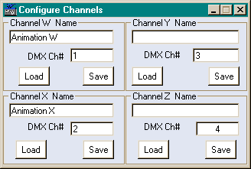

Program Editor:
The Programmer also features a simple editor that allows control data frame data to be edited. To access this window click on the “View Data” button in the Programmer’s main window. This will bring up a spreadsheet like window as shown below.

To edit the data in a frame, select the channel via the radio buttons and go to that frame and enter the new data. You can also enter data in consecutive cells by entering the Start Frame and the End Frame, then entering the Start and End Value (0-255). The program can perform a linear fill over the selected range by clicking the Fill button. You can also clear the data in the range by clicking the Clear button.

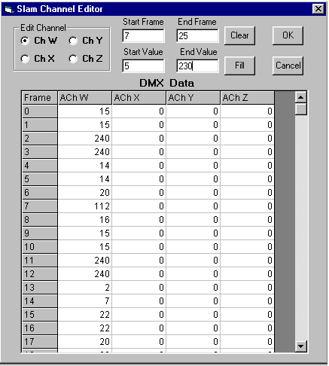

DMXEdit
The DMX Program is not intended for use with the rPod but may be used to edit control files created with the Programmer or from onboard capture commands.

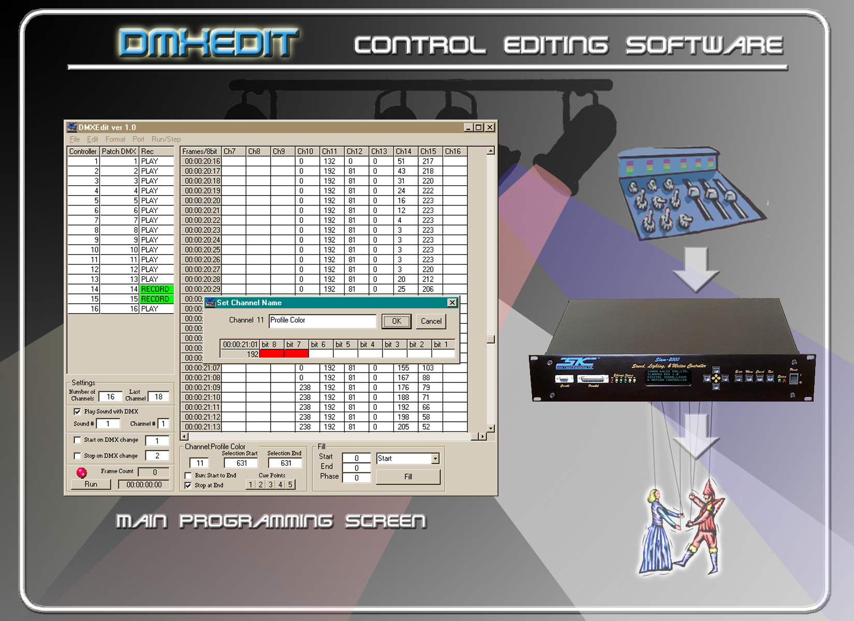

Loading a New Operating System

The rPOD-8.4 has two processors each requiring an operating system. The main and safest way to install new Operating System (OS) is to copy the rPodp1aXXX OS file (with .ldr extension) onto one CF card and the rPodp2XXX file (with .ldr extension) onto another CF card. Next, insert the CF card with rPodp1aXXX into CF Card 1 slot and the rPodp2aXXX CF card into the CF Card 2 slot. Now connect the rPOD’s console port to a host computer’s serial and using a terminal program such as Hyperterminal (set for 115Kbaud 8 bits, 1 stop bit, no parity), power up the rPOD and then on the terminal program use the “Install” command followed by the name of the OS file without the .ldr extension and a Return on the keyboard.

Example for Processor 1: Install rPodp1a063.ldr <Return>

You should see status on the terminal program and generally less than a minute the load should take place. Now move the serial cable to the DTE port of the rPOD (you may need to adapt the green euro-style connector to a DB-9 and sometimes require a null-modem connector) and do the same command with the rPodp2aXXX file:

Example for Processor 2: Install rPodp2a2063.ldr <Return>

The default drive for processor 1 is Card 1 (directory A in the Software Description Manual) and Card Slot 2 for Processor 2 (directory B in the Software Description Manual). You can use the change directory command (see rPOD8.4 Considerations and File Access Commands in the Software Description Manual), to stay connected to one serial port and even use one card with both OS files and via “cd a” and “cd b” commands change directories for installing. Repower the unit or use the “Boot” command only after installing the OS on both processors. You can also issue the Install, cd a, cd b, and Boot commands via Ethernet (if you have an Ethernet capable OS already installed) using a UDP Terminal Program like Hercules. More on Ethernet commands can found in the SKE Software Description Manual.

FAILSAFE BOOT PROCEDURE TO RESORE A UNIT THAT HAS LOST ITS OS

You should never disconnect power while loading the OS. This can cause a problem in the loading and saving process. Of course, this circumstance can happen by accident or due to an unforeseen power failure. For this reason and a failsafe protection scheme, there is an alternate method for serial loading of the OS. There are two Boot Jumpers BOOT1 and BOOT2 (Items 16 and 17 in the rPOD layout picture. Use the following procedure:

- With power off, install BOOT1 and BOOT2 Jumpers. These jumpers are two pin jumpers for each location. If you have a unit with one pin cut on the BOOT1 and BOOT2, connect the uncut pin of each to one of the nearby GNDTP1..X test points.
- Power up the unit. If you are monitoring on a serial port you should see a BOOT splash screen.
- Remove the BOOT jumpers.
- Perform the normal “Loading a New Operating System” process.

The unit should now be fully functional with the new operating system.

Key Features and Specifications

- 4.5 stereo or 8 mono audio outputs. Multi-channel polyphony feature.
- 16 to 24-bit PCM Audio. Up to 48.1 Khz sampling. Maximum number of messages limited only by CF card size.
- Embedded digital signal processing (DSP) including seven-band EQ, compression/expansion, subwoofer crossover, ducking, cross-fading, independent track and channel volume controls.
- Differential audio line outputs, audio line and microphone inputs with on-board analog to digital converters.
- Dual Compact Flash Interfaces (CF cards sold separately).
- 8 discrete bits of digital output control, high or low side switching via optically isolated 125mA(typical) drivers.
- 8 optically isolated input triggers with high or low-side triggering.
- RS-232/RS-485 interfaces allow programming, triggering and additional control. A DMX-512 in and out for control expansion.
- The Sequence Programming and emulation system provides a Powerful PLC language for user scripting of event triggering, audio playback, output control, DMX-512, audio channel and track volume and ducking, and many other functions.
- Sequence programming language capability: 32 concurrent processes.
- On-board real-time clock with backup battery. Real-time event triggering through sequence programming.
- Operating system can be upgraded in the field.
- Recommended Power Supply: 12-26 Volts DC @ 2 Amps (5 Amps Max).
- One year warranty.

Specifications and appearance are subject to change without notice.

Warranty
Simon-Kaloi Engineering, Ltd. ("SKE"), warrants this product to be free from defects for a period of one year from the date of purchase. If this product is defective under warranty, it must be returned to SKE or authorized service representative with proof of purchase (shipping costs for service are not covered by the warranty). This warranty is in lieu of all other warranties, expressed or implied, including, but not limited to, the implied warranties of merchantability or fitness for particular purpose, which are hereby expressly disclaimed. Warranty service must be performed by SKE or by SKE authorized service representative. Unauthorized service invalidates the warranty.

LIMITATION OF LIABILITY
SKE shall not be liable for any damage due to accident, abuse, misuse, normal wear and tear, or exceeding manufacturers specifications. The only remedy for breach of warranty is repair or replacement at the sole discretion of SKE. SKE shall not be liable for any incidental or consequential damages for breach of any expressed or implied warranty. SKE shall not be liable for any damage, whether arising in tort, contract or otherwise, for any amount in excess of the dealer cost of the product. Any claims for breach of warranty or contract must be brought within one year of acceptance of the product. Notice of such claims must be received by SKE within 60 days after acceptance of the product.

All of the information in this document is believed to be accurate at the time of print however due to the dynamic nature of this product, all features, specifications, and other information are subject to change without notice.

31192 La Baya Drive Unit G • Westalke Village, CA 91362
Phone: (818) 707-8400 • Fax: (818) 707-8401
Website: email: sales@skeng.com

